Facebook is part of many people’s life. Connecting with friends and others, setting up events and much more. But what happens to this information and page when a person dies?
There are several options for your Facebook account.
- Legacy account
- Deleting an account
- De-activating
However, this is something that will need to be put into action while the Facebook user is still alive.
Deleting Facebook Account
You can choose to have your account permanently deleted after death.

To do this:

1. When logged into Facebook Click

2. Select Settings

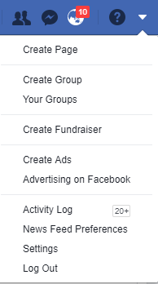

3. Then click: Manage account.

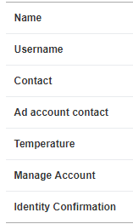

Modify your legacy Contact settings or deactivate your account

4. Click: Request account deletion

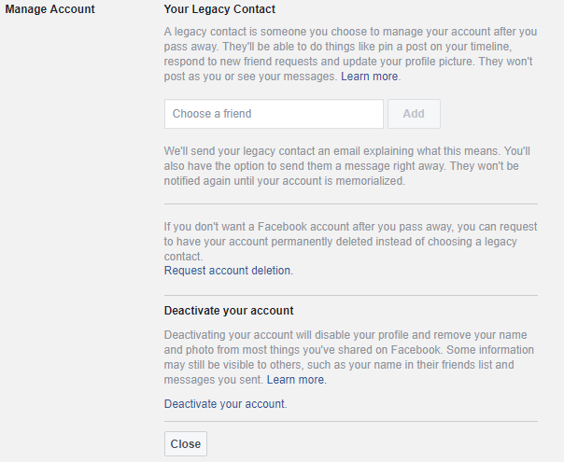

5. This message will appear.

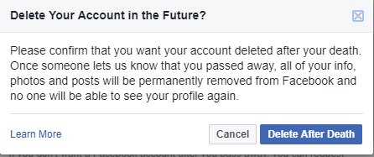

6. Click: Delete After Death

With this information, Facebook will make the changes to the user account when they receive a copy of the death certificate.

Thank you to Facebook for this information

https://www.facebook.com/help/224562897555674?helpref=faq_content

Reminder:
There might be other accounts that need to be closed. For example Twitter, eBay any on-line accounts and email accounts.

Reviewed 01.2019 CF
Last Days of Life Care – Te Ara Whakapiri
Social Media

Social Media Facebook
Account

If you are concerned or unsure about anything, please discuss this with the Care Team supporting you.

