Ways carers can help when a person is in pain

If the person can talk
- Look for non-verbal signs of pain
- Ask them if they feel pain at rest – use same language as they would have used e.g. sore, discomfort etc.
- Ask the person questions about their pain using an appropriate tool e.g. OLDCART
Onset:
When did it start?
Location: Where is it and does it spread out to other areas?
Duration: How long does it last?
Off and on or continuous?
Characteristics: Describe the pain.
Stabbing, cramp like
Aggravating factors: What makes it worse?
Relieving factors: What makes it better?
Treatment:
What medication are being used –
Prescribed, traditional, recreational or
over the counter preparations.
What non-pharmacological interventions
are being used.

Ask the person to tell you about their pain and illness history, and examine them for bruises, swelling or breaks in the skin.

If the person cannot talk:
(Consider normal/previous facial expressions)
Look for signs and sounds that show pain
- Frowning, grimacing (use FACE pain scale)
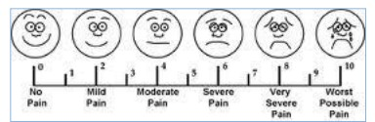
- Grunting, groaning
- Fidgeting, moving legs
- Agitation, trying to get out of bed
- Not wanting to move
- Seeming more confused or restless

Abbey Pain scale can be accessed
from;
www.dementiacareaustralia.com

Management
- Each person experiences pain differently.
- Changing the persons position can help reduce stiffness and muscular aches and provide pressure relief. It may be beneficial to do some massage or passive movement prior to changing position.
- Distraction can help reduce some types of pain by helping the person to relax. Have the patient choose some music, guided audio CDs/MP3’s, to listen to, watch TV, or encourage them to relive happy memories.
- Consider any previous pain-relieving methods such as:
- TENs machine
- Aromatherapy
- Hot or cold wheat pack. Take care that the pack is not burning hot. Monitor the person closely.
- Massage and touch can help, if the person agrees. Those giving massage need to understand clearly what may help and what may harm.
- If appropriate for the person, prayer and mindfulness meditation can help relieve pain or existential suffering.
- Just spending time quietly alongside the person, reading or chatting, can reduce pain levels.

For more information:
https://www.healthnavigator.org.nz/health-a-z/p/palliative-care/care-in-the-last-few-days-of-life/

http://www.hospice.org.nz/

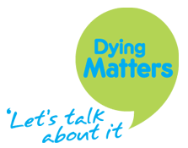

https://www.dyingmatters.org/page/being-someone-when-they-die

We would like to thank Mercy Hospice for sharing their resources.

Reviewed 01.2019 CF
Last Days of Life Care – Non-Pharmacological
Pain Management

Pain management
‘Ways you can help without medication’

Important for use alongside appropriate pain medication

This pamphlet offers suggestions of support for yourself and those around you should it be needed.

