Breathlessness can be frightening for the person and the family/carer

Words that may be used to describe this sensation:
- Suffocating
- Drowning
- Smothering
Can add to the anxiety of any person
Assess the level of breathlessness.

Breathlessness is what the person tells you, using a structured tool like either one below. Allows the person to score their level of breathlessness 1-10

No breathlessness

Severe breathlessness

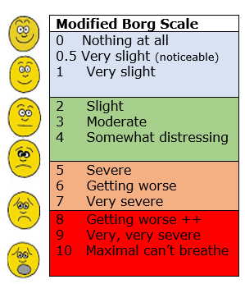

Positioning

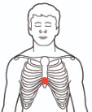
Keep lungs open and free to allow comfortable breathing.

Here are some ways you can help relieve breathlessness.
This may be done alongside the use of prescribed medication.
- Use pillows to support the head and neck. Avoid tri-pillows, as the person can slip into the hollow space, and this position makes breathing more difficult as the head bends forward closing airway
- Support the arms to help release tension in the shoulders and keep lungs open.

Environment
- Make sure the room is light and well ventilated.
- Check that the person is wearing loose clothes and can move easily in bed
- Fan air gently across the face. (not directly on the face)
- A cool damp cloth, or fine mist spray, on the face can also help.

Relaxation/Anxiety Reduction
- It is important for you to stay and speak calmly.
- If the person consents, gentle stroking on the upper arm.
- The person may mimic your calm breathing if you have your hand on their shoulder or their hand and breathe more slowly. “breathe in through the nose and out through the mouth.”
- These words may be verbalized if appropriate and
reassure the person.
- The breathless person may find it relaxing to have a gently hand or foot massage using aromatherapy oils. (Avoid strong smells – consider what the person finds comfortable)
- Play music the person has chosen.

REMEMBER – AVOID
- HOT WATER AND HUMID ENVIRONMENTS
- TRI PILLOWS
- SAYING THINGS LIKE - “JUST KEEP CALM”

For more information:
https://www.healthnavigator.org.nz/health-a-z/p/palliative-care/care-in-the-last-few-days-of-life/

http://www.hospice.org.nz/

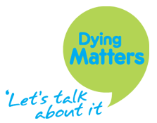

https://www.dyingmatters.org/page/being-someone-when-they-die

We would like to thank Mercy Hospice for sharing their resources.

Reviewed 01.2019 CF
Last Days of Life Care – Non-Pharmacological
Breathlessness

Breathlessness

‘Ways you can help without medication’

This pamphlet offers suggestions of support for yourself and those around you should it be needed.

